COAL Lab 03 Assignment:

# Name: Owais Ali Khan

# Section: 3-F

# Roll no: 21K-3298

Question # 01:

TITLE Question 1

; This program adds and subtracts 32-bit integers.

INCLUDE Irvine32.inc

.DATA

val1 SWORD ?

val2 SBYTE -10

.CODE

main PROC

mov ax, val1

mov bl, val2

call DumpRegs ; display registers

exit

main ENDP

END main

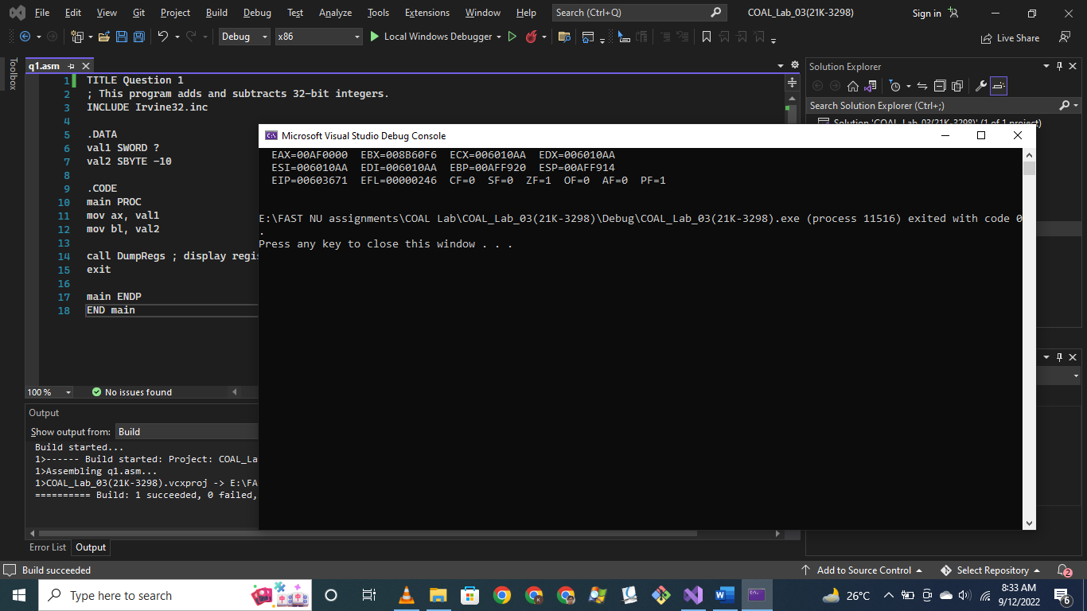

Question # 02:

TITLE Question 2

INCLUDE Irvine32.inc

.DATA

val1 SDWORD -2147483648

.CODE

main PROC

mov eax, val1

call DumpRegs ; display registers

exit

main ENDP

END main

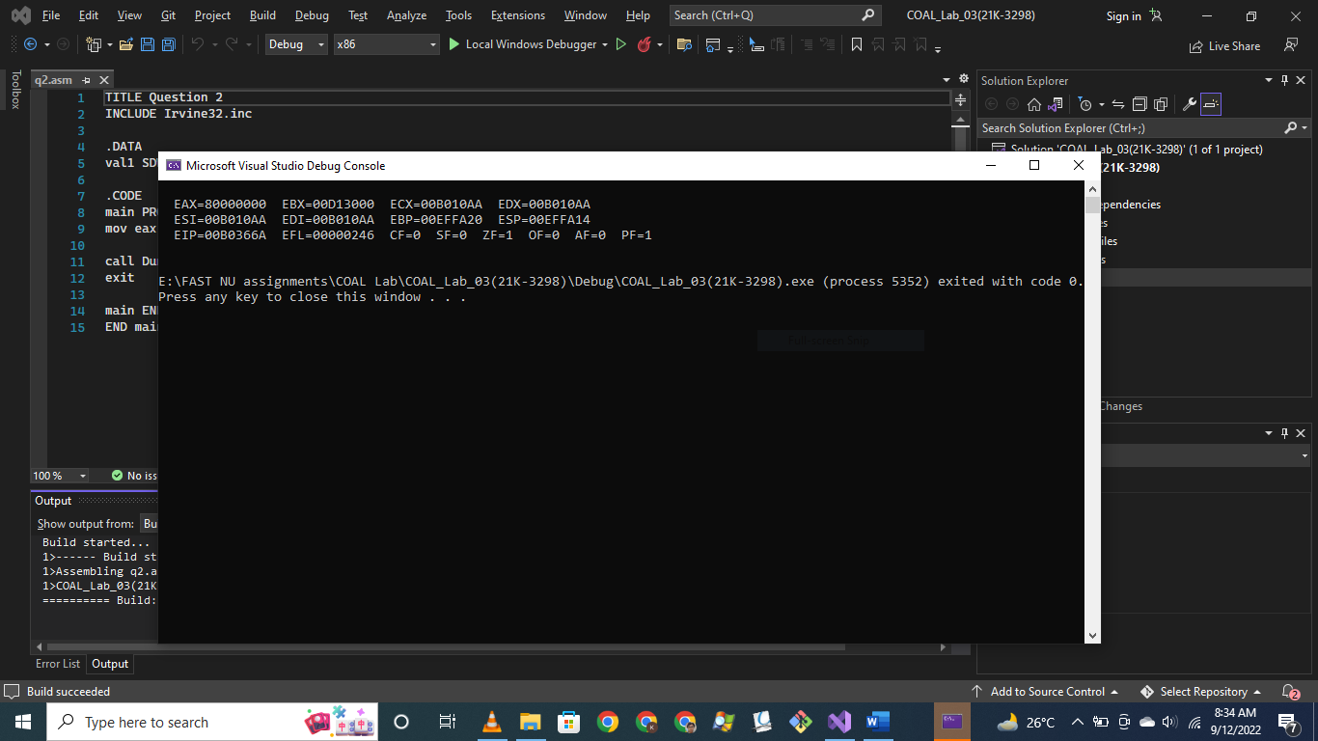

Question # 03:

TITLE Question 3

INCLUDE Irvine32.inc

.DATA

wArray WORD 1,2,3

wArray2 DWORD 1,2,3

.CODE

main PROC

mov ax, wArray[0]

mov bx, wArray[2]

mov cx, wArray[4]

;mov eax, wArray2[0]

;mov ebx, wArray2[4]

;mov ecx, wArray2[8]

call DumpRegs ; display registers

exit

main ENDP

END main

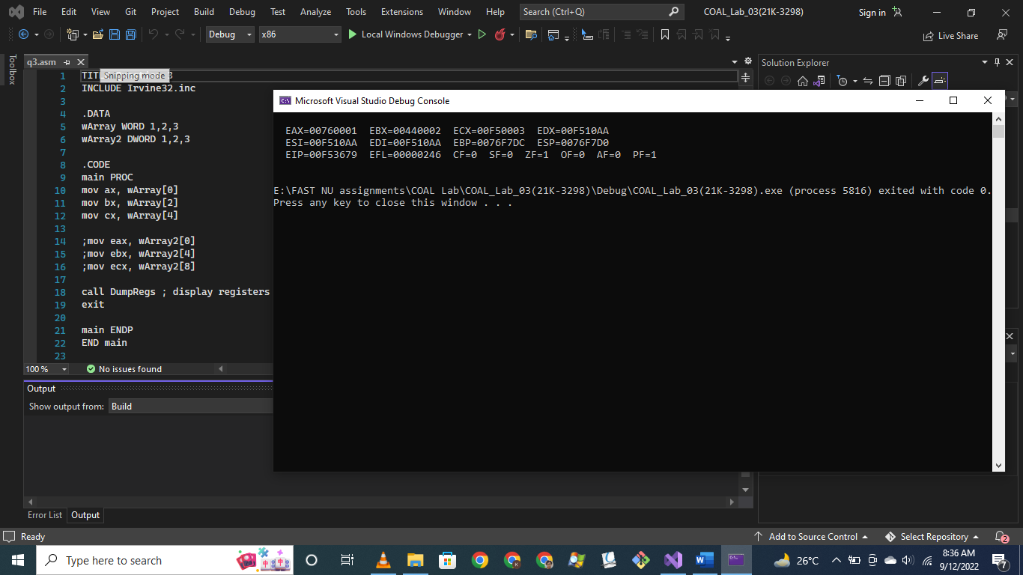

Question # 04:

TITLE Question 4

INCLUDE Irvine32.inc

.DATA

color BYTE "Orange", 0

varA WORD 12

varB WORD 2

varC WORD 13

varD WORD 8

varE WORD 14

.CODE

main PROC

mov ax, varA

mov bx, varB

mov cx, varC

mov dx, varD

mov si, varE

call DumpRegs ; display registers

mov edx,offset color

call writestring

exit

main ENDP

END main

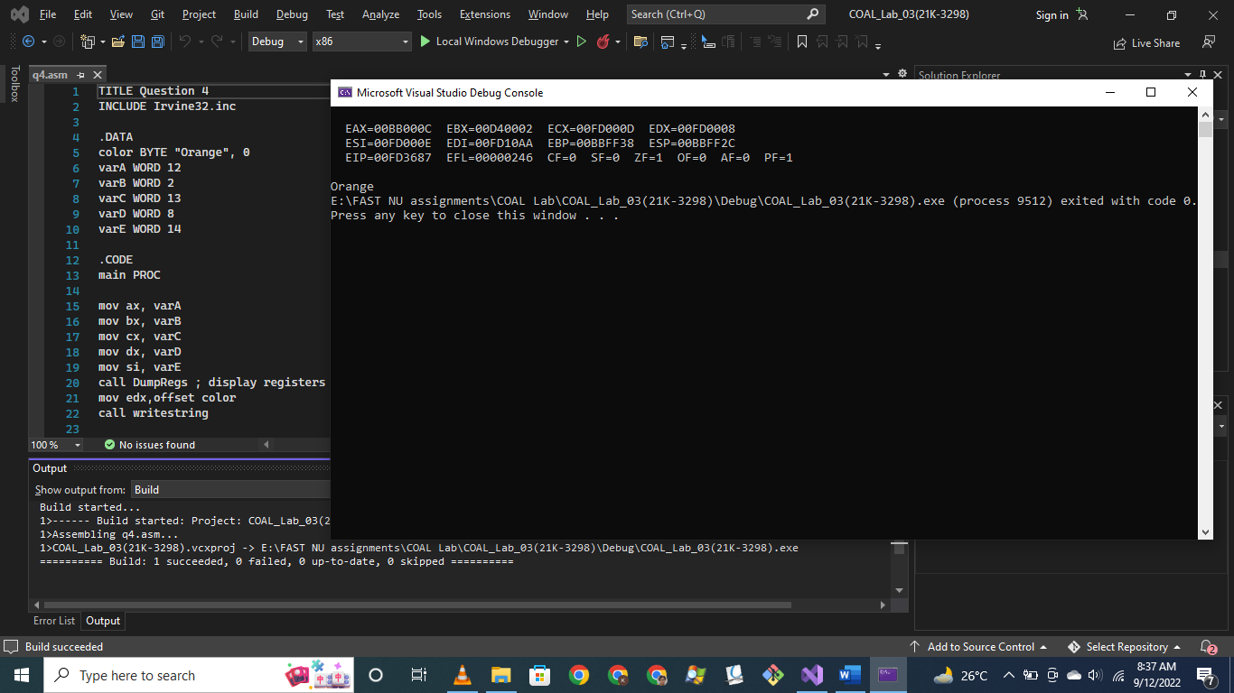

Question # 05:

TITLE Question 4

INCLUDE Irvine32.inc

.DATA

varA DWORD 10h

varB DWORD 15h

varC DWORD 20h

varD DWORD 30h

.CODE

main PROC

mov eax, varA

mov ebx, varA

mov ecx, varC

mov edx, varD

add eax, varB

sub ebx, varB

sub eax, ebx

add eax, ecx

add eax, edx

mov ebx, eax

call DumpRegs ; display registers

exit

main ENDP

END main

;ebx = { (a+b) – (a-b) + c } +d

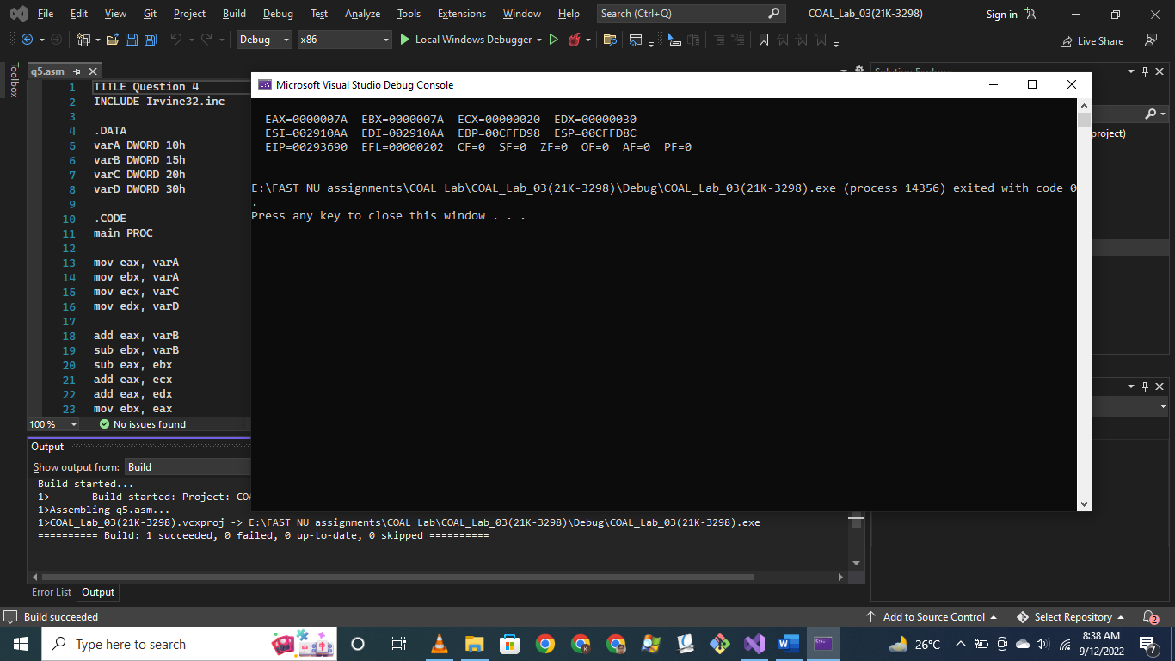

Question # 06:

TITLE Question 6

INCLUDE Irvine32.inc

.DATA

varA BYTE 00010000b; 10h

varB BYTE 00010101b; 15h

varC BYTE 00100000b; 20h

varD BYTE 00110000b; 30h

.CODE

main PROC

mov eax, 0

mov ebx, 0

mov ecx, 0

mov edx, 0

mov al, varA

mov bl, varA

mov cl, varC

mov dl, varD

add al, varB

sub bl, varB

sub al, bl

add al, cl

add al, dl

mov bl, al

call DumpRegs ; display registers

exit

main ENDP

END main

;ebx = { (a+b) – (a-b) + c } +d

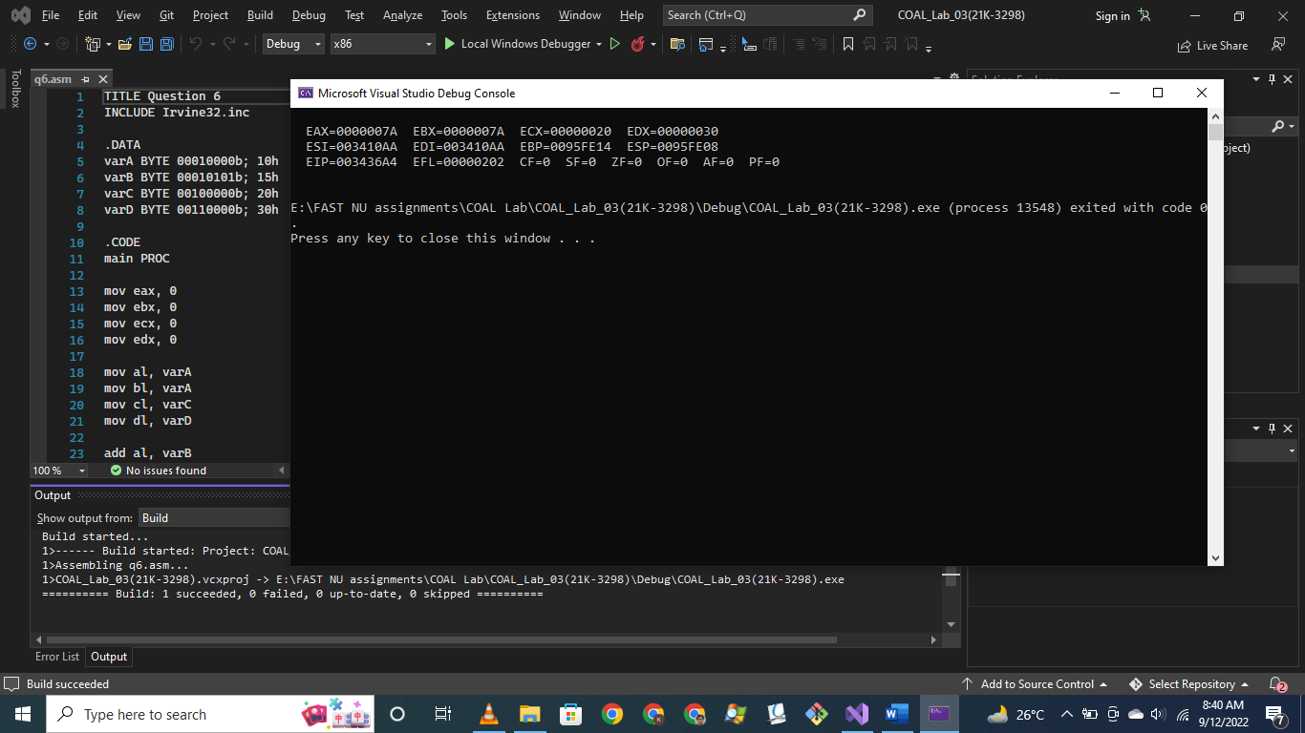

Question # 07:

TITLE Question 7

INCLUDE Irvine32.inc

.DATA

Imm8 equ 20

data1 WORD 8

data2 WORD 15

data3 WORD 20

.CODE

main PROC

mov eax, 0

add al, imm8

add ax, data1

sub ax, data3

add al, imm8

add ax, data2

call DumpRegs ; display registers

exit

main ENDP

END main

;Eax = imm8 + data1 – data3 + imm8 + data2

